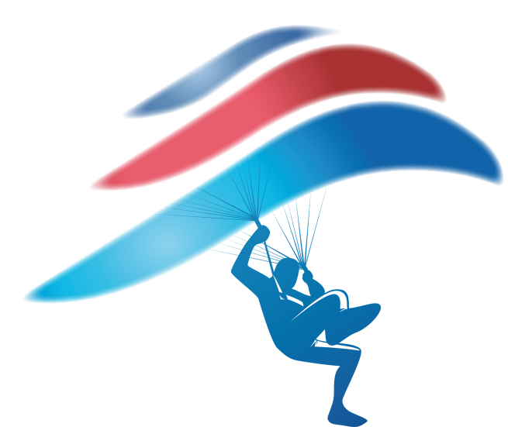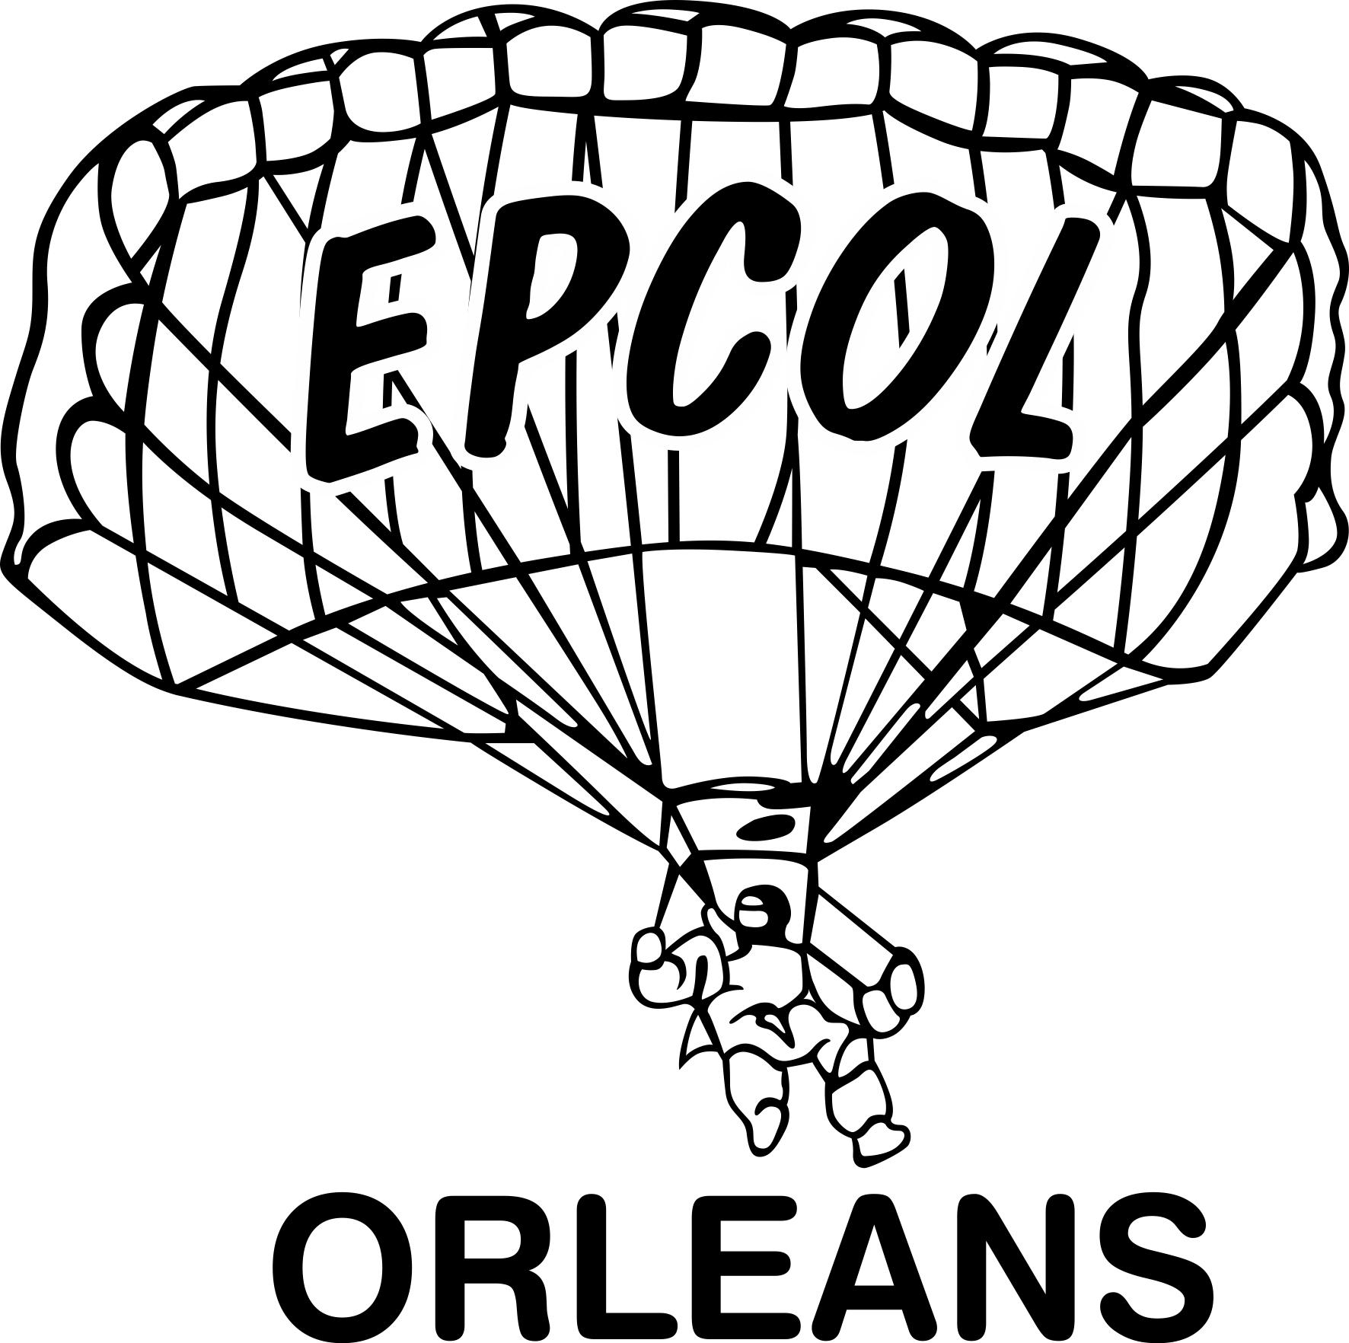

3rd International open Canopy Piloting competition

Saint Denis de l’Hôtel, Orléans
3rd – 6th September 2020
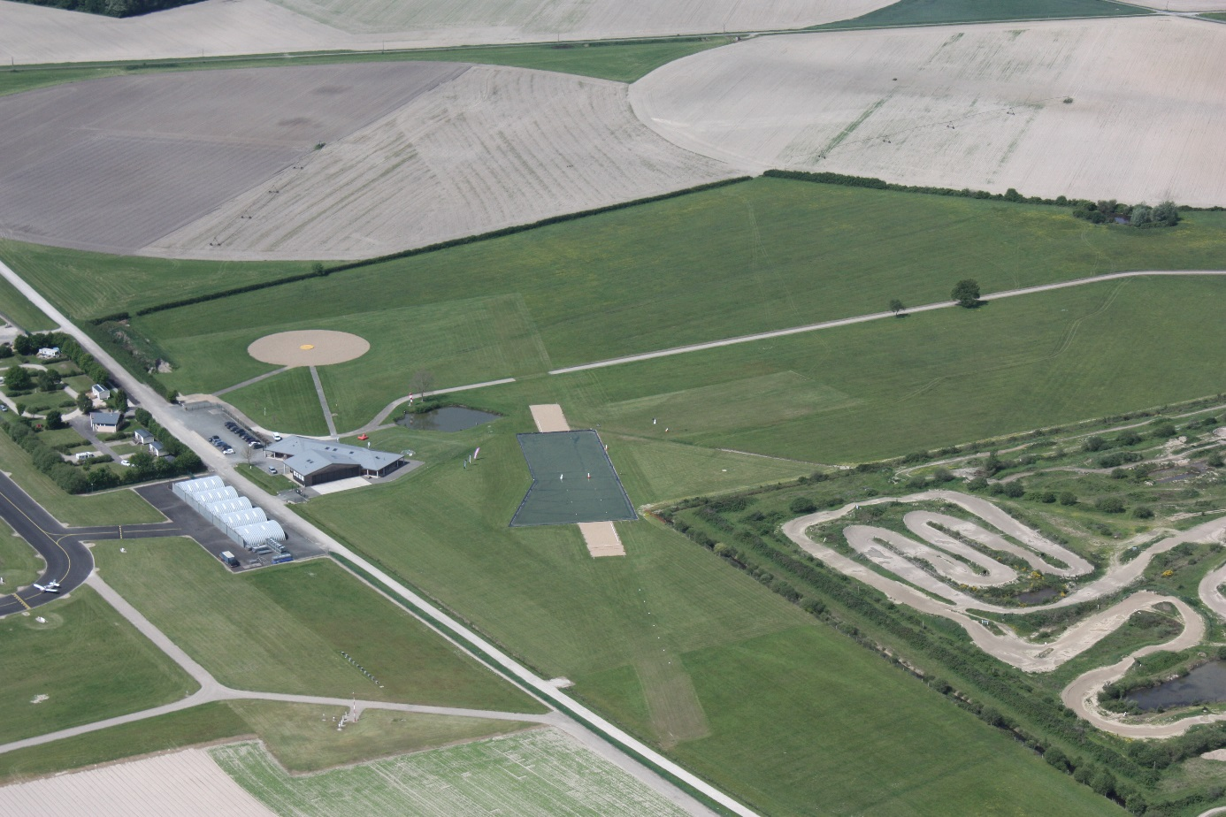
Organized by “Ecole de Parachutisme du Centre Orléans Loiret” France.
Under the authority of the French Parachuting Federation

VENUE:
- Loiret Airport - 45550 Saint-Denis de l'Hôtel
N47°54'9'' E2°10'10'' https://goo.gl/maps/bunjzWYFEXT2

EQUIPMENT:
- Personal Requirements: For personal requirements including FAI Sporting License (see Sporting Code, Section 5, § 1.2)
- An AAD and a helmet is mandatory (French legislation)
- The airworthiness of parachuting equipment used is the responsibility of the competitor and registration will be taken as a declaration by the Delegation and competitor that the parachuting equipment to be used is certified as being airworthy by competent authorities (see FAI Sporting Code, Section 5, 5.1.1 [1]).

AIMS:
- To promote safety and exchange experience, knowledge and information between participants.
- To establish international relationships among parachutists.
- To promote Canopy Piloting.

SCHEDULE:
The skydiving center will be open from August 31 to allow competitors to train on the swoop pond.
Thusday 3th September
- 14H: Official training jump
Friday 4th September
- 8h15: Briefing.
- 8h45 competition starts, jumps until sunset.
- 20h00: Dinner on the airport.

Saturday 5 th September
- 08h00: 1st call – Competition jumps until sunset.
- 20h00: Dinner on the airport.

Sunday 6 th September
- 08h00: 1st call – Remaining competition jumps.
- 14h00: End of the competition.
- 16h00: Award ceremony.

ACCOMODATION - reservation and payment in advance
- Lunch - dinner on site: /person: 10€
- Gala dinner: /person: 25€

- Camping and caravaning on site: contact@loiret.aeroport.fr
+33-238463333
- There are also Hotels and B&B around the Drop Zone (car required).

RULES
FAI Competition Rules (CR) for the Open event (https://www.fai.org/sites/default/files/documents/2020-isc_cp_rules.pdf)
French Federation rules for the advanced (N2) event:
http://www.ffp.asso.fr/wp-content/uploads/2013/02/FFP-PSV-2017-1.pdf

JUDGES
FAI Judges and approved national judges will be used for all events.

JUDGING EQUIPMENT
- In Time CP Scoring System

AIRCRAFT
- Pilatus Porter & Cessna 207 Soloy

TRAINING JUMPS
- Training jumps are available on the DZ.

INSURANCE
- Personal Health insurance and repatriation coverage are the responsibility of each participant and is highly recommended.
- Liability insurance coverage to third parties is required and is responsibility of each participant/parachutist.
- Any damage to hotel rooms etc. is the responsibility of the persons involved.
- Personal items and equipment are the responsibility of each participant.

MEDICAL FACILITIES
Adequate medical services will be provided at the drop-zone during the event

TRANSPORTATION
It is under the responsibility of the teams.

INSCRIPTION FEE
- 50€
JUMPS COST
- Canopy Piloting 9 rounds – 18€/jump

PRIZE MONEY OVERALL
- First place 600 euros
- Second place 500 euros
- Third Place 400 euros
- Fourth place 300 euros
- Fifth place 200 euros

REGISTRATION FORMS/REGISTRATION
Contact by mail: contact@parachutisme-orleans.net
Web Site: http://parachutisme-orleans.net/
Facebook page: https://www.facebook.com/events/600791480073519/

- The Final Registration Form and necessary Documents must be submitted before August 22th.

Bank account:
Account name: C.E.LOIRE-CENTRE
IBAN: FR76 1450 5000 0108 1002 8802 328
BIC: CEPAFRPP450

https://jepaieenligne.systempay.fr/epcol

